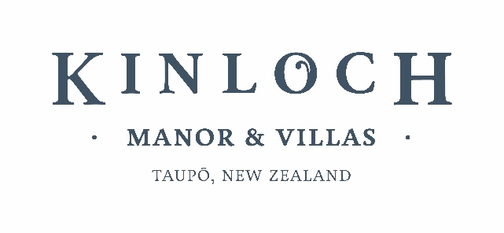

For immediate release
LAUNCHING KINLOCH MANOR SIGNATURE WALKS
Tongariro Alpine Crossing and Lake Taupo
18 DECEMBER 2023, Taupo New Zealand. Kinloch Manor & Villas now offers guests the experience of world class walking trails, combining exceptional food and wine with staying at New Zealand’s leading luxury lodge. Our first Signature series includes one of New Zealand’s most popular one day hikes – the Tongariro Alpine Crossing a 19km/12mile walk across an active volcano and World Heritage Site acknowledged for both its natural beauty and cultural value. The Alpine crossing is known for its steam vents, emerald lakes and impressive craters, reaching over 1800 metres in elevation. If conditions aren't suitable, or you'd prefer an easier day, your guide will show you the best of Tongariro National Park taking in rivers, valleys, and mountain views on shorter walks.
Day by day …
The lodge has a minimum two-night stay, but this experience is best as a three-night/four-day, Taupo and Tongariro National Park experience including luxury accommodation at Kinloch Manor & Villas, private guides and drivers and all meals. Our suggested itinerary is to arrive at Kinloch Manor and take our complimentary cycles for a short ride through the Redwood Forest to the shores of Lake Taupo. Pre-dinner drinks and canapes each evening start at 6.30pm followed by a 4 course degustation dinner following our estate to plate dining philosophy, using produce reared from our sister lodge Treetops Lodge estate and local artisan producers. Wake up and depart after an early breakfast to a private guided hike on the Tongariro Alpine Crossing - one of New Zealand's best day hikes. We will provide a full backpack gourmet lunch and snacks. An optional transfer one or both ways by helicopter can be arranged to view the spectacular national park from the air. After a more leisurely gourmet breakfast on the second morning, depart on a non- guided walk from our local Kinloch village on the private Great Lakes Trail walk to pretty Kawakawa Bay where you can be met and enjoy a private cruise on Lake Taupo with gourmet lunch and wines. Also, during your stay, at a time of your choice, enjoy a one hour muscle relaxing massage in our dedicated spa. Your final morning enjoy maybe a lakeside walk to start the day followed by a freshly prepared gourmet breakfast before a late morning departure from the lodge. Additionally, we can arrange visit to Huka Falls and a two hour walk in the Spa Park.

For more information on Signature Walks at Kinloch Manor & Villas contact reservations@thekinlochclub.com or for media enquiries karine@navigateoceania.com or phone +64 21753022.
END
More about Kinloch Manor & Villas & The Kinloch Club
The lodge was designed by award winning architect Andrew Patterson and acclaimed interior designer Virginia Fisher. The 18 luxury villas offer accommodation spaces of junior suites, 1 and 2-bedroom villas just a short stroll from the lodge all with landscaped views over the golf course to Lake Taupo.

Using organic reared produce in the restaurant, sourced from nearby sister lodge Treetops Lodge & Estate with 2,500 acres of 100% pesticide free virgin forest and gardens, cuisine at Kinloch is matched with fine New Zealand wines. Complementing the championship golf course is an on-site Spa and tennis courts.

Perfectly placed on a 254ha spectacular setting above the shores of Lake Taupo, heart of New Zealand’s internationally recognized adventure and wilderness playground, is the uber-luxury lodge Kinloch Manor & Villas set beside The Kinloch Club, golf course. Kinloch Manor offers lodgings to discerning lovers of natural beauty and cutting-edge lodge design, complementing their on-site, 18-hole Jack Nicklaus designed Signature Golf Course. The superb Kinloch Club has twice been voted #1 Golf Course in New Zealand by a select team of New Zealand Golf Professionals and as winner of USA Golf Digest ‘Best International Golf Resort’ and 2023 World Golf Resorts – Best Golf Resort
Recent Awards:
2023: Winner World Golf Awards – New Zealand’s #1 Golf Resort
2023: USA Golf Magazine – Awarded in Top 10 Nicklaus Courses Asia Pacific
2023: Golf Headquarters - #2 in top New Zealand Golf Courses
2023: USA Golf Magazine - Ranked in top 100 Asia Pacific
2021: USA Golf Digest - Winner ‘Best International Golf Resort’
2020: #1 public playable Golf Course in New Zealand by a select team of New Zealand Golf Professionals year on year
2019: #1 Golf Course in New Zealand by a select team of New Zealand Golf Professionals year on year
2018: Golf Digest – Winner Best in New Zealand
2017: Winner, New Zealand grand award winner – ‘Architecture of the Year’
2017: #1 Golf Course in New Zealand by a select team of New Zealand Golf Professionals year on year

